Minutes of the General Meeting of the Comstock Grizzlies
Saturday April 19th @ 2 PM
Dan and Tom’s Home – Carson City, NV

General information and attendance:

Meeting called to order @ 3:20 PM by President Ken

Meeting Attendee’s:
Dan, Tom, Jason, Jim .S, Nathan, Ken, Thomas.
Tat, Steve R., Max, Dean, Larry, Jim, Kyle, Anthony

Attendee’s: 15

March 2025 minutes were sent to group.

Motion to approve as sent.
Motion: Max Second Jim, Approved by acclimation.

Current information for these minutes.
Treasurers Report: Through 03/15/2025

Previous Balance: $ 530.46
Transactions: IN $ 00.00
Ending Balance: $ 530.46
Net Change: $ + 00.00

Motion to approve the Treasury Report.
Motion: Max Second Jim, Approved by acclimation.

Although dues are not required to attend activities.
We are all encouraged to renew your dues
and look at friends to become members.
Just so we have funds for our club expenses.

Web/Facebook Report:
FULLY UPDATED

Old Business:
None

New Business:
Several Suggestions were made for our Spring / Summer
Activities. Details to be attached and discussed at the next
Meeting.

Next DNO will be at:

May 2025


Thai Lotus
6430 South Virginia, Reno, NV 89511
Wednesday May 7th @ 6:30 PM
Reservation for 10 made.
Separate checks should not be an issue.

Pot Luck Dinner and Club Meeting – Typically the 3rd
Saturday of the month

There was a suggestion and discussion on having
a theme for our dinners. After discussing we decided
to give it a try. It is a meal suggestion, not a requirement.
Just have FUN with it. Feel free to bring what you wish.

Next Meetings:
May Meeting:

No theme for dinner this time.
Saturday May 17th at Ken and Nathan’s Home @ 6:30 PM

June Meeting and Annual Beer Bust

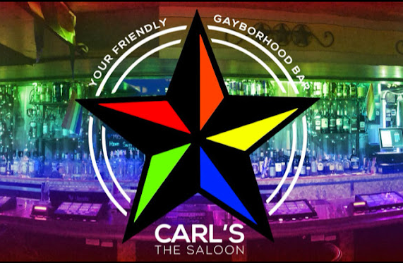

June 21st from 3pm – 6pm
Details to attached.
Meeting to follow Beer Bust

Hope to see you all there.

Close the meeting:
Motion: Max Second Jim, Approved by acclimation.
Approved at 3:41 PM.

Respectfully Submitted
Nathan C. Secretary April 25, 2025
SPRING AND SUMMER PLANNING INFORMATION

GAME NIGHT AND ICE CREAM SOCIAL (NO DINNER)
Hosted by Nathan and Ken.
Date to be determined.

POKER NIGHT WITH SNACKS (NO DINNER)
Hosted by Nathan and Ken.
Date to be determined.
Suggested $20 Buy-in.

MAGIC CARPET MINI GOLF
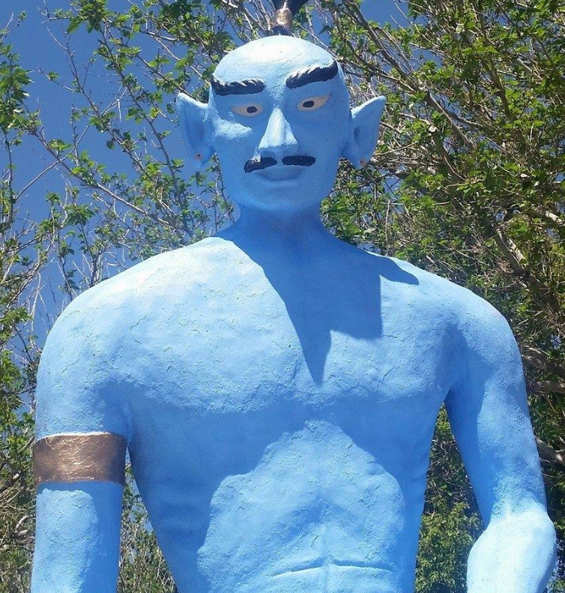
6925 S. VIRGINIA ST. RENO, NV 89511
COST $13 Cash $13.52 Card.

BOCCE BALL
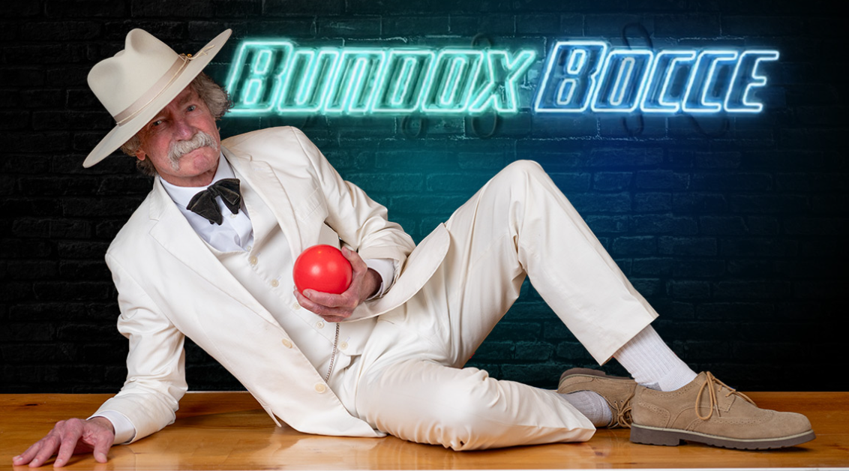
Renaissance Reno Downtown Hotel & Spa
One Lake St, Reno, NV 89501

The court Cost $30 for 50 minutes of play.
They also have full bar and food.

BOWLING NIGHT
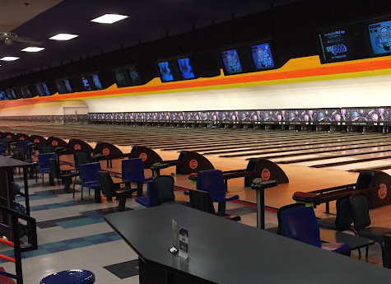
Located inside the Grand Sierra Resort & Casino,
2500 E 2nd St, Reno, NV 89595

COST $16 Per person per hour.
OR
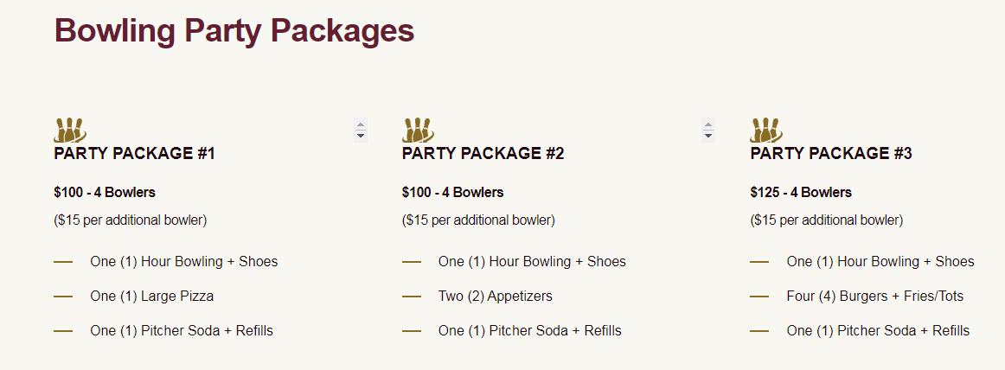

TRIP TO RENO ANIMAL ARK
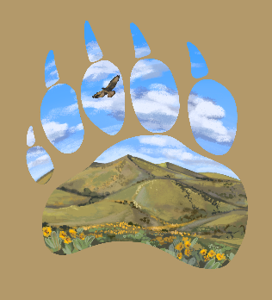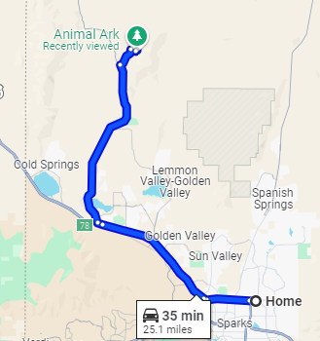
1265 Deerlodge Road. Reno, NV

This should be planned for a Saturday or Sunday.
Morning is best for viewing animals. Cost $20 / $16 Seniors.
Tickets only available online.
It is a 35 minute drive for our house so carpooling is suggested.

ACES BASEBALL NIGHT
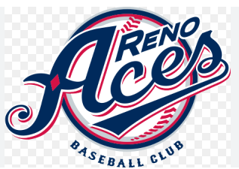
GREATER NEVADA FIELD

We are looking at several gates and games. The cost varies accordingly. Sould end up being between $30-40.
It looks like ticketes must be purched online.
I am offering to buy the tickets and be reinbursed for them.
This way we make sure we have seats together.

TRIP TO LAKE TAHOE – NEVADA BEACH OPTION
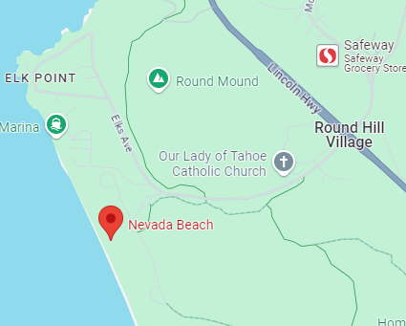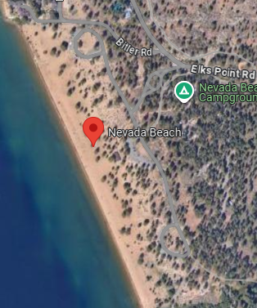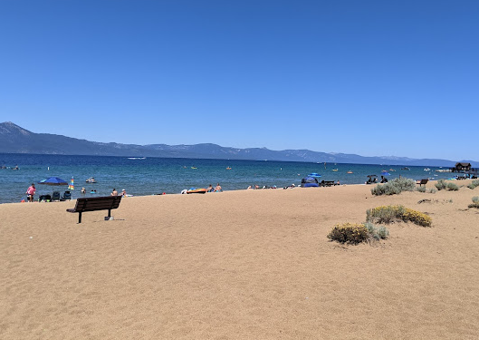

This outing had a few options. Sand Harbor, Dixie Cruise or Nevada Beach.
In my opinion Sand Harbor could be problematic because of the new reservation system. The boat tour was pricey for two hours ($99) and getting tickets on line
could be difficult to coordinate. So I chose to plan a trip to Nevada Beach.
They seem to have ample parking and have restroom services. Looks like an easy walk to beach. I would suggest that we car pool. There is a parking entrance fee.

